Control Systems Laboratory
Lab 2
Fuzzy PID and Genetic Controller Design for an Inverted Pendulum
Akshit Patel (2018A8PS0094P)

- Inverted Pendulum
An inverted pendulum is a pendulum that has its center of mass above its pivot point. It is unstable and without additional help will fall over. It can be suspended stably in this inverted position by using a control system to monitor the angle of the pole and move the pivot point horizontally back under the center of mass when it starts to fall over, keeping it balanced. The inverted pendulum is a classic problem in dynamics and control theory and is used as a benchmark for testing control strategies.

- Transfer Function
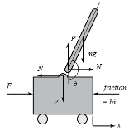

Transfer function obtained from mathematical model of inverted pendulum is
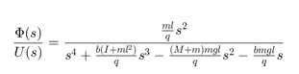

- SIMULINK Model Parameters
  - (M) mass of the cart 0.5 kg
  - (m) mass of the pendulum 0.2 kg
  - (b) coefficient of friction for cart 0.1 N/m/sec
  - (l) length to pendulum center of mass 0.3 m
  - (I) mass moment of inertia of the pendulum 0.006 kg.m^2
  - (U) force applied to the cart
  - (x) cart position coordinate
  - (theta) pendulum angle from vertical (down)
  - (phi) pendulum deviation from vertical position(from pi)
- Normal PID Tunin
  - Model
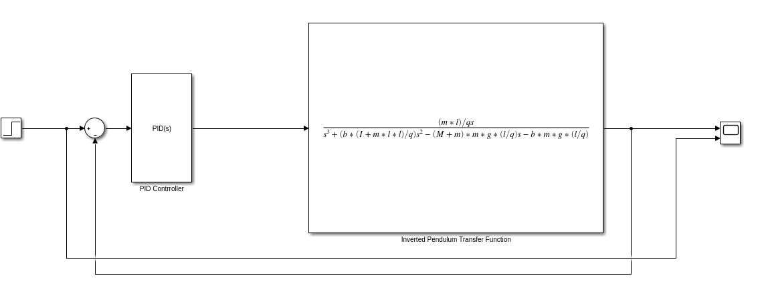
  - Parameters
    - Gains [Kp Ki Kd] = [1320 7880 40]
  - Outputs
    - Step Response Graph
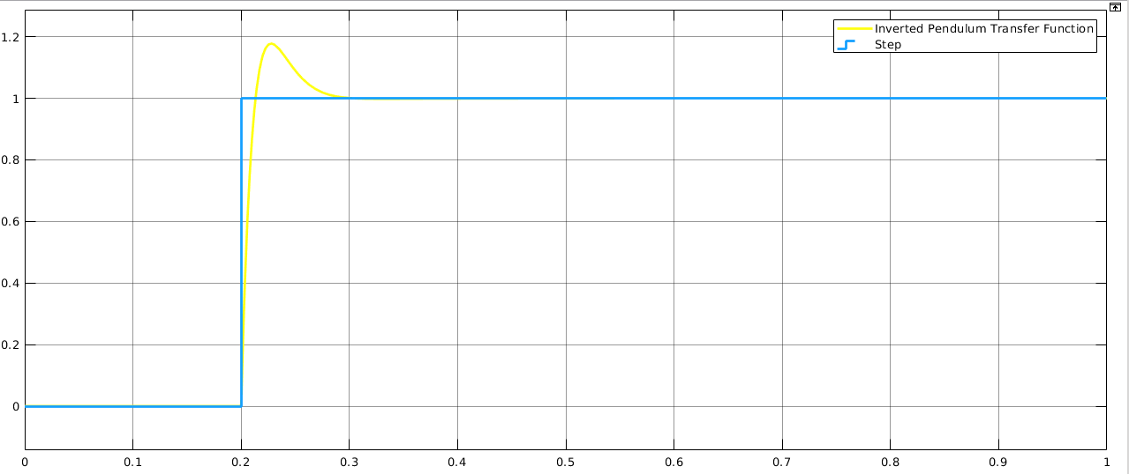
    - Overshoot: 0.176
    - Rise Time : 0.080 (for 2%)

- Genetic PID tuning
  - Model
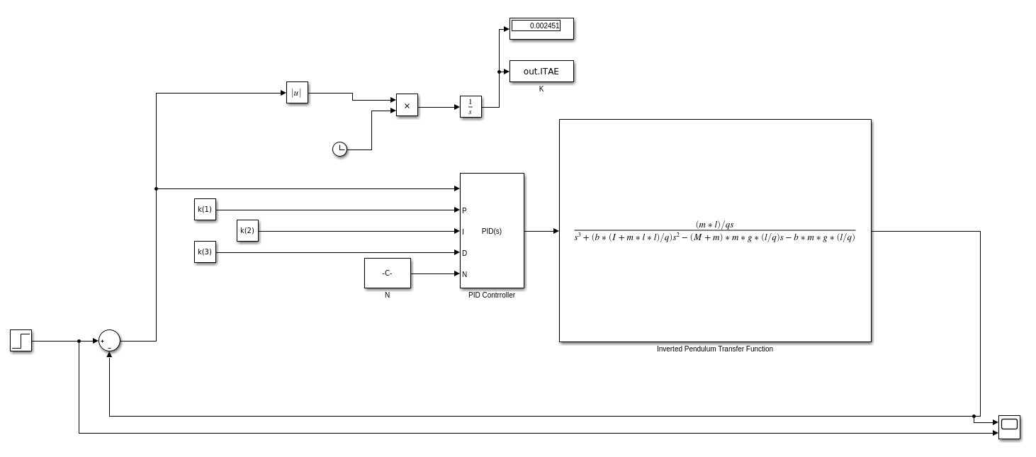
  - Paramters
    - Max Generations:10
    - Population Size:30
    - Scaling Function: Rank
    - Mutation: Adaptive Feasility
    - Crossover Function: Arithmetic
    - Else all default
  - Outputs
      - Gains: [Kp Ki Kd] = [1315 7876 35]
      - Generations
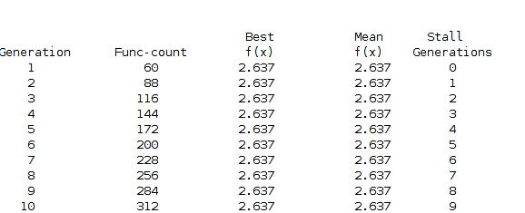
      - Step Response
a.Graph-
b.Overshoot: 0.144
c.Settling Time: 0.078(for 2%)

- Fuzzy PID Controller
  - Model
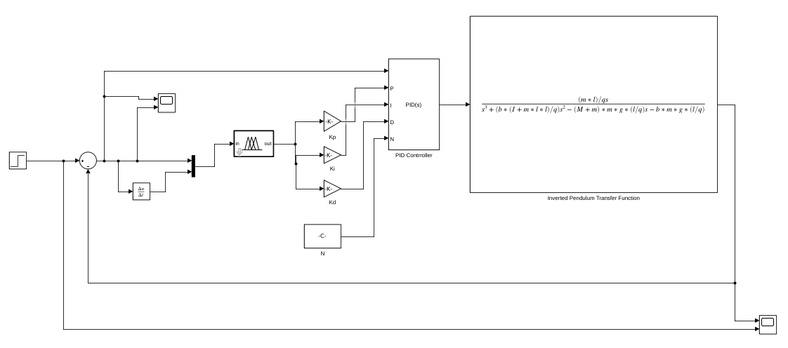
  - Parameters
      - Membership Functions of e and Rate of error
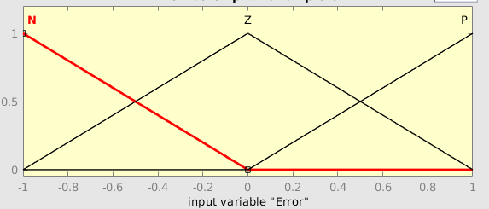
      - Membership Functions of output
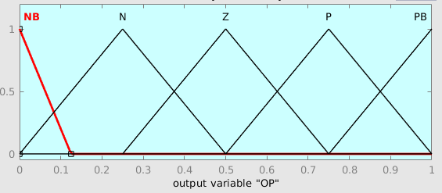

      - Gains Kp Ki Kd = [1754.667 10501.92 46.925]
      - Output Surface
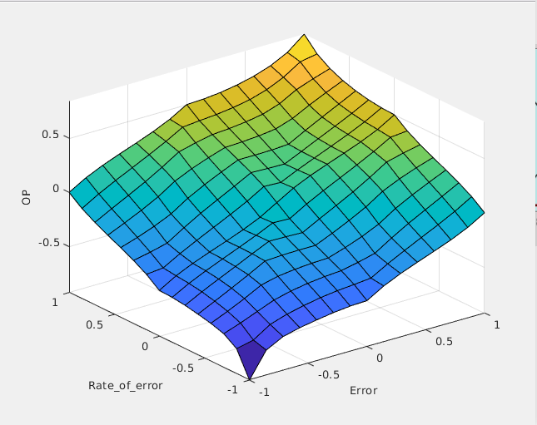

  - Output
    - Step Response
      - Graph
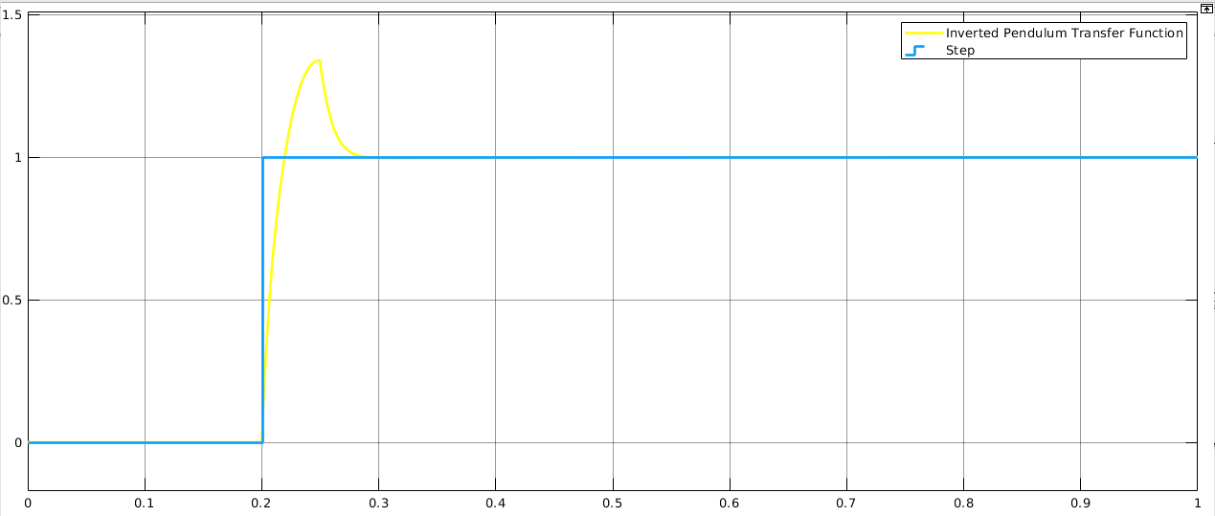
      - PeakOvershoot 0.338
      - Rise Time 0.074 (for 2%)
7. Results

